Joseph Scherreik

Prof. Katsinis

CS-281-B

8 December 2020

Final Exam

Problem 1:

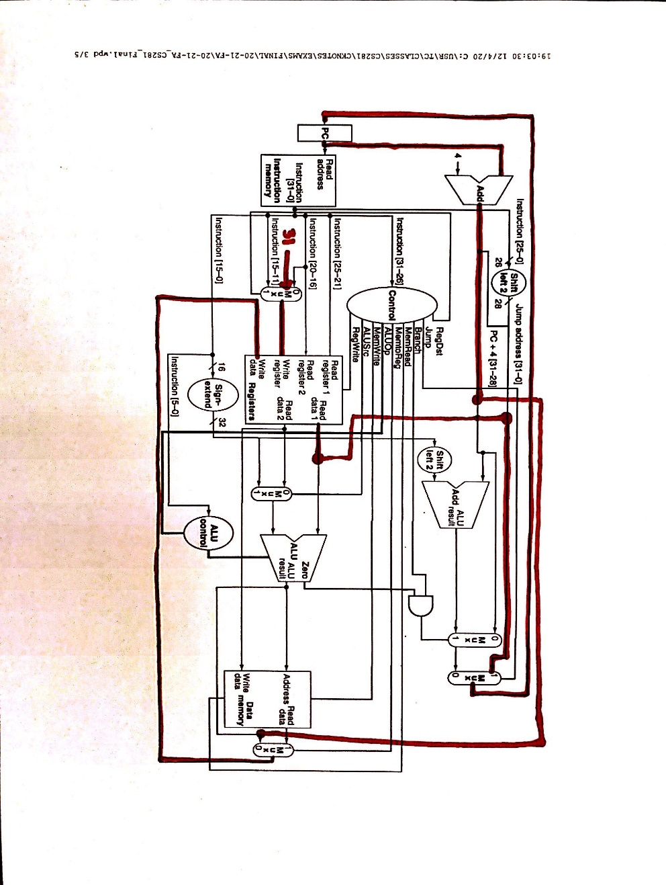

I added 2 new control signals. One connects the Adder for PC to the Mux after the Data Memory. The other one connects Read Data 1 to the Mux that eventually leads back to PC.

Problem 2:

1. The lw instruction takes the current element in the array(s0) and, puts it into memory(mem($v0+0). The sw instruction takes the memory address of current element in the array(s0) and places it into a registry(v1).
2. We want to increment this before storing the address of p because we are editing the v0.